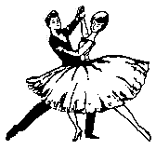

Valentines
Round Dance Special
Phase II thru Phase V

Friday, February 13, 2009
7:00PM – 10:00PM

Alamo Palms RV Resort
1341 W Business 83
Alamo, Texas

Enjoy an evening of Round Dancing
with

Nancy & Dewayne Baldwin
&
Shirley & Don Heiny

$8 Per Couple

