NELSON’S ROUND DANCE SCHEDULE
RIO GRANDE VALLEY in Pharr, TX
December 2007 – March 2008
[Start Monday, Dec 1]

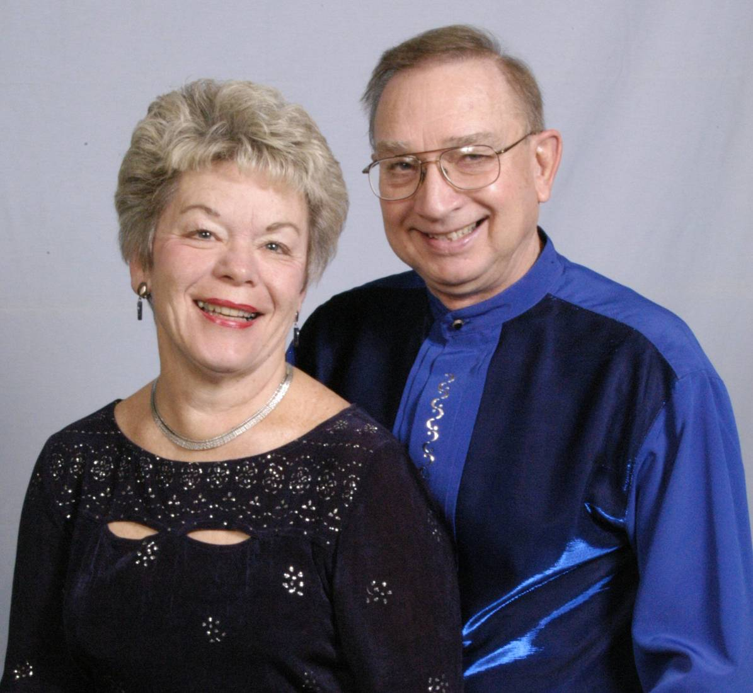
Tropic Star Ballroom
1401 S.Cage
US 281 South
Pharr, TX 78577
Adrienne & Larry Nelson
1401 S. Cage Unit 703
Pharr, TX 78577
956-783-5787
319-830-6819 cell [Adrienne]
515-480-6889 cell [Larry]
Lnelson888@juno.com

MONDAY
10:00 a.m. PH IV-V Workshop Tropic Star
1:00 p.m. PH V-VI Workshop Tropic Star
6:30 p.m. Pre-Rounds/Plus w/ Joe Saltel Tropic Star

WEDNESDAY
1:00 p.m. PH II & Intro to PH III Figure Clinic Tropic Star
6:00 p.m. PH III-IV Party Dance Tropic Star
8:00 p.m. PH IV-VI Party Dance Tropic Star

THURSDAY
10:00 a.m. PH IV-V-VI Rhythm Clinic Tropic Star
1:00 p.m. PH III & Intro to PH IV Figure Clinic Tropic Star

FRIDAY
10:00 a.m. PH V Figure Clinic [Except 1st Friday] Tropic Star
1:00 p.m. PH III-IV Workshop Tropic Star
6:00 p.m. PH III-IV Classic & Oldies Dance [Once/Month] Tropic Star
7:30 p.m. PH IV-V-VI Classic & Oldies Dance [Once/Month] Tropic Star
[Dec 28, Jan 11, Feb 8, Mar 7]

SATURDAY
10:00 a.m. Beginner Basics [Starting Jan 5] Tropic Star
7:00 p.m. Pre-Rounds/Plus w/ Joe Saltel Tropic Star

SPECIAL DANCES MONTHLY = TBA
WORKSHOPS = Teaching a Dance Routine
FIGURE CLINIC = Teaching Figures Rhythms per month TBA
*Hearing Enhancement System available at all sessions ***Schedule Subject to Change

