**EAA Chapter Member Survey**

***June 2017***



**Summary and Chapter Results**

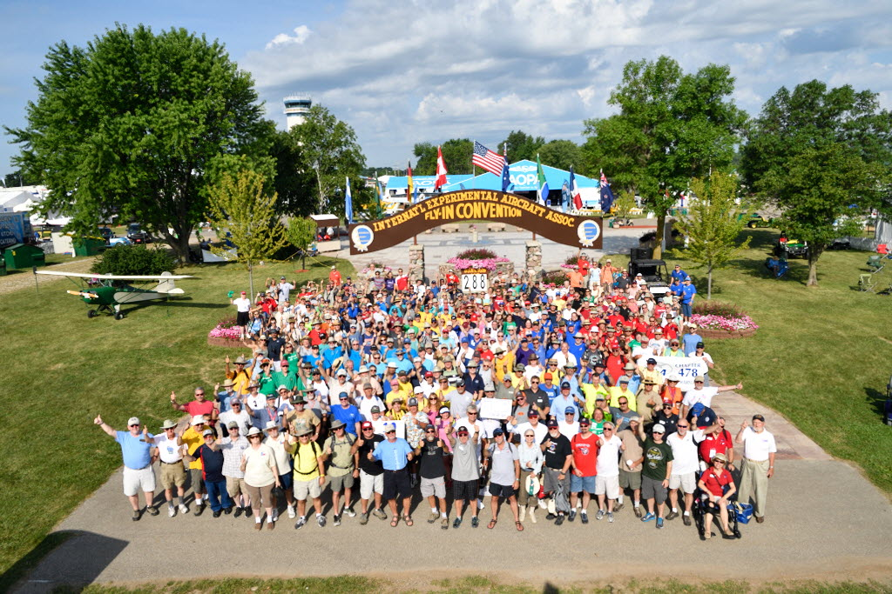

**Introduction**

The following report is a **review of the aggregate results from the chapter member survey**. **Your chapter scores may differ from the following results**. Within this document, you will see a high-level overview of the survey and what your chapter can take away from the aggregate results.

The summary begins with breakdown of who is or is not a part of a chapter. You may be interested to see the number of members who took this survey who are not current chapter members.

Following a review of who is or is not a part of a chapter, you will find a breakdown of why these members are or are not a chapter member. In addition, there are responses that cover how members learned about their local chapter

The section pertaining to the question that asked, *“How likely is it That You Would Recommend your EAA Chapter?”* is the longest section of this summary, due to the importance of the question. This section covers the aggregate scores on a scale of 0-10, as well as why members gave those specific scores.

You will also find an overview of chapter activities. This section compares how active chapters are in specific activities versus how important members find these activities. These scores are the aggregate for the chapter network and may differ compared to your chapter’s scores.

A measure of chapter meeting satisfaction is also included in the summery. A review of the scores given and what they mean for chapters is covered in this section.

While reviewing this report, please remember that these are the aggregate results for all EAA Chapters, and that your chapter’s results, found in the excel spreadsheet which was sent to you, may differ from those within this report.

**Overview:**

Typically, the more engaged and involved members take part in surveys sent out by EAA. What this indicates is that there is a large group of members who have never been a part of a chapter or have departed their former chapter.

|  |  |
| --- | --- |
| **The top 3 reasons for never being a part of a chapter were as follows** | **The top 3 reasons for leaving a chapter were as follows:** |
| 1. None nearby- 34% 2. Not aware/not invited- 22% 3. No time- 21% | 1. Too far/no time- 46% 2. Poor Experience/Poor Leadership- 27% 3. Chapter closed- 10% |

**Takeaways:**

Addressing those who have never been in a chapter-

To increase the visibility of your chapter, you are encouraged to review the numerous resources at your disposal. These resources include but are not limited to, promotional emails sent to local EAA members and customizable marketing materials.

Visit [EAA.org/ChapterResources](https://www.eaa.org/en/eaa/eaa-chapters/eaa-chapter-resources) to see what is available to your chapter.

Addressing those who have never been in a chapter- cont.

Many individuals will not go out of their way to visit your chapter unless you increase awareness and extend a personal invitation. Many open ended responses stated “I was never invited, so why should I attend?” ***The personal invite is key to attracting new members.***

Addressing those who used to be chapter members-

Obviously, it is difficult to create more time in one’s life. However, by creating benefit to your programs (i.e. food, social time, and speakers/presentations) the chapter may become a higher priority for members. One major area that the chapter can control is creating a better overall experience. Focus on fostering a welcoming environment. Share a meal together, wear nametags, greet new guests as they arrive, and make the members feel valued. Listening to what your members have to say will also help guide the chapter in the correct direction.

**Members who are Part of a Chapter (Columns C & D)**

**Overview:**

|  |  |
| --- | --- |
| **How did you find out about your EAA Chapter? (Column C)** | **Why did you decide to join your EAA Chapter? (Column D(** |
| 1. Word of Mouth- 60% 2. Internet research- 25% 3. Chapter event/activity- 7% | 1. Aviation camaraderie and activities- 37% 2. Aircraft building/learning- 31% 3. Knowledge & skill building/learn to fly- 11% 4. To promote general aviation – 11% |

Although word of mouth was the most common way that members learned about their chapter, internet research cannot be overlooked. EAA has seen a steady growth of members joining via the web, so that 25% will also continue to grow for chapters. You must have an online presence that is regularly maintained. ***A lack of online presence or out of date material will indicate that the chapter is inactive.***

For those who joined a chapter, it is interesting to note that the vast majority of members joined for the following reasons: Aviation camaraderie, aviation education, or simply aviation related activities.

**Takeaways:**

Three legs hold up the EAA stool. Those legs are education, social, and aviation. These match up perfectly with the reason why members join chapters. By keeping your chapter focused on these three points, then you are more likely to keep your members interested and engaged.

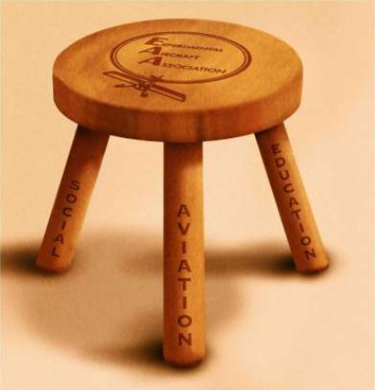

**How likely is it That You Would Recommend your EAA Chapter to a friend or colleague? (Column E)**

***(Scale of 0 – 10)***

**Overview:**

In marketing, this question is one of the most telling measures of how much your customers enjoy your product. The score measures the willingness of customers to recommend a company's products or services to others. It is used as a proxy for gauging the customer's overall satisfaction with a company's product or service and the customer's loyalty to the brand.

For ease of viewing, ***we did not calculate the score using the normal method***; instead, we simply scored on a scale of 0-10. Scoring an 8 – 10 indicates an individual would recommend your product, while scoring a 0 – 7 indicated that a customer would not recommend your product.

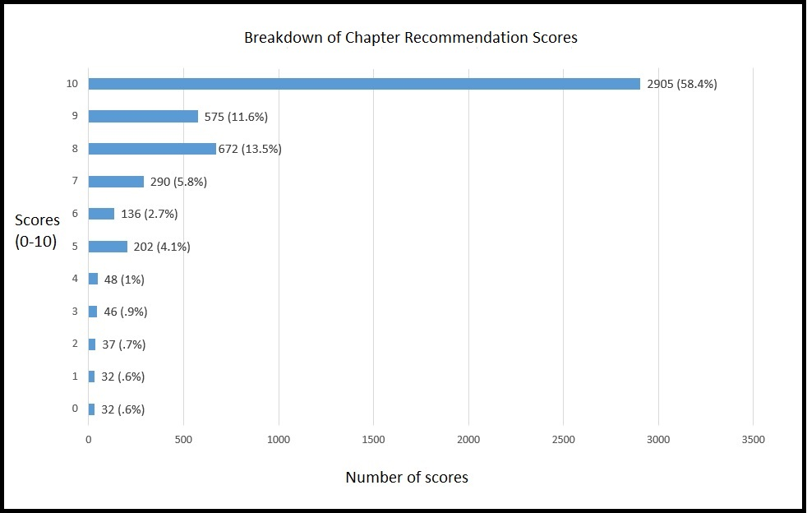

Your chapter’s average recommendation score is at the bottom of column E. An average from 0 to 8 was considered low, 8 to 9 ok, and 9 to 9.5 would be a good score. Scoring anything above a 9.5 would be a great score. Once above a 9.5, it is hard to improve, as you are approaching the point of diminishing returns.

**Average overall recommendation score for all chapters = 8.82**

**How likely is it That You Would Recommend your EAA Chapter to a friend or colleague? - cont.**

|  |  |
| --- | --- |
| **Why members would recommend the chapter (9-10):** | **Why members would not recommend the chapter (0-6):** |
| 1. Lots of activity- 28% 2. Knowledgeable/Helpful members- 23% 3. Friendly/welcoming members- 15% 4. Promotes aviation/YE program- 14% 5. Building activity/assistance- 13% 6. Diverse set of activities- 6% | 1. Lack of activity or boring- 42% 2. No building activity- 23% 3. Members aging out- 13% 4. Not a welcoming group/cliques- 12% 5. Poor Leadership/Vision- 10% |

**Takeaways:**

The breakdown of why members would and would not recommend their chapter shows a very clear trend. ***Activity equals success***. Very rarely are there chapters that are losing members who are also very active. Typically, the most active chapters are the most successful chapters.

If your chapter is currently not hosting many activities and has been losing members, you may be saying, “We can’t have a fly-in or a Young Eagles rally because we don’t have enough volunteers.” Do not fret. It is ok to start small. Consider hosting a monthly grill out at a member’s hangar, take a field trip to a local aviation attraction, or another low commitment, easy to plan event. You will gradually be able to host larger events as more local members take notice of the chapter’s activity.

Unsurprisingly, chapter members are very interested in learning, specifically about homebuilding. Lack of education and building activities proved to turn away members, while on the flipside, members really enjoyed chapters with building and knowledge sharing. Although building is very important, many of the open-ended comments revealed there are a large number of non-builders who like to take part in a variety of aviation activities. With this in mind, it is important to not let your chapter become one-dimensional. Try not to become too fixated on only building or only Young Eagle events. Keeping activities diverse will encourage more involvement from members with different interest areas.

The last point of interest is how the inclusiveness of a chapter really influences whether or not members would recommend their chapter. Keep in mind, it can be very difficult to walk into a new group of individuals and feel a part of the group. This can be especially difficult when the chapter members are more experienced in different areas of aviation.

It is important to welcome each member with a high-level enthusiasm. Make sure each member knows that they are a valued member of the chapter. This is where a smile, a handshake, nametags, and an introduction to fellow members will go a very long way.

**How Active is your Chapter in the Following Activities (Column G – R) v.**

**How important are the Following Activities to You (Column S – AD)?**

*Scale of 1-5: 5- Very Important, 3- Somewhat Important, and 1- Not Important At All*

**Overview:**

Largely, many of the activities that chapters take part in are aligned with the level of importance that chapter members placed in those activities. The following activates showed the largest difference between what the chapter was taking part in versus level of importance.

1. ***Educating the local community about general aviation***
2. ***Connecting with other aviation enthusiasts***
3. ***Presentations on building/restoration/maintenance*.**

The graph below list activities in order of how large the discrepancy was between how active a chapter was, versus how important chapter members felt an activity was. The larger the negative delta, the bigger the disparity between what a chapter was taking part in, versus what the members felt was most important.



**Takeaways:**

When looking at your individual chapter score, attempt to identify what areas your chapter members are most passionate about, and then check to see if they think your chapter is very active in that area. If there seems to be a large discrepancy between what the chapter is doing and what the members want the chapter to be doing, then look into incorporating more of those activities. You may also find that the chapter is putting a lot of energy into a specific activity that the members do not find much value. Ensure that your chapter adjusts accordingly.

**Are you satisfied with your chapter’s regular meetings? (Column AF) *(Scale of 1-5)***

*Scale of 1-5: 5- Very Satisfied, 3- Somewhat Satisfied, and 1- Not Satisfied At All*

**Overview:**

When evaluating our programs at EAA, we always ask members to rate their satisfaction on a scale of 1-5, as we did with the satisfaction of monthly chapter meetings. When analyzing these scores, we have determined the following:

**Scores:**

**Less than 4:** Something is wrong, and major overhauls to the program should be considered

**4 to 4.25:** The program is ok, but there is room for improvement.

**4.25 to 4.50**: The program is good, but there is room for minor improvement.

**4.50 and Above:** The program is great, and the law of diminishing returns takes effect.

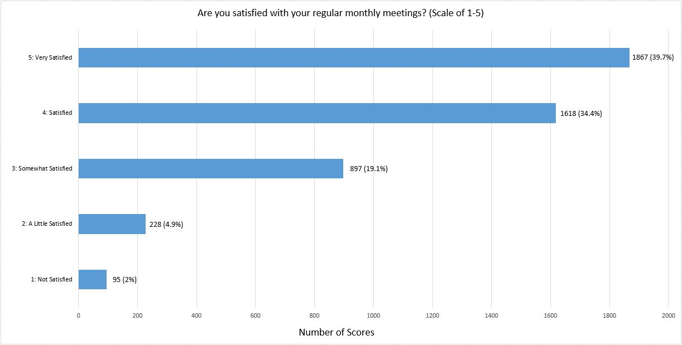

**Takeaways:**

Most chapter members find their monthly meeting to be good, but there is still room for improvement.

To help boost member-meeting satisfaction, look at open-ended suggestions as well as what activities your chapter members find important. This will help your chapter incorporate more programing that members will enjoy.

**Chapter Member Demographic Questions**

**Overview:**

The information below is provided to your chapter, so that you may measure how your chapter’s demographics match up against the sum of the chapter network. On your chapter’s survey results the age, gender, and length of time in the chapter were removed to help individuals remain anonymous. They are, however, included in this summary of chapter member demographics to help you get an estimate for how your chapter may stack up against the chapter network at large.

**How long have you been a member of your chapter? (Not included on individual survey)**

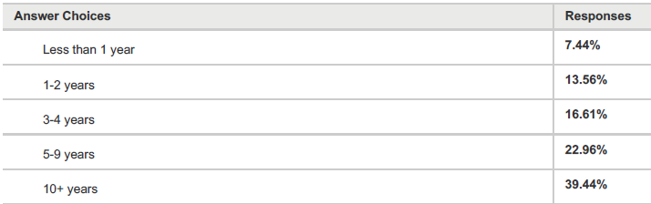

**What is Your Gender? (Not included on individual survey)**

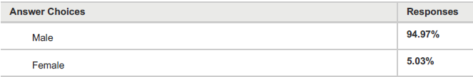

**Please enter your age. (Not include on individual survey)**

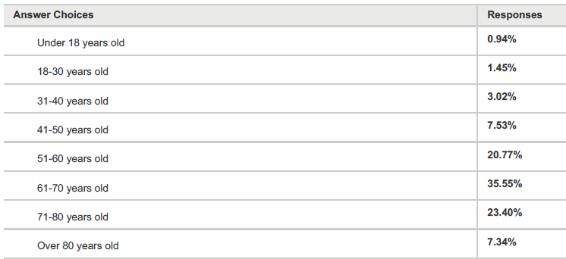

**Are you a pilot? (Column AI)**

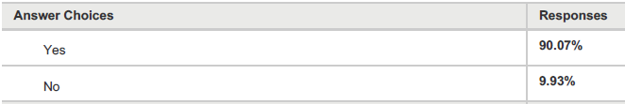

**Do you have any experience with flight training? (Column AJ – AN)**

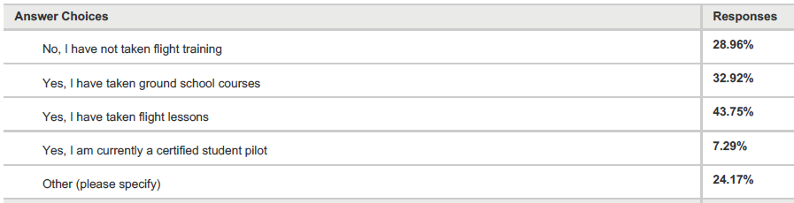

*\*Other (Please specify) is included as open ended commentary in column AN\**

**Do you have interest in attaining your pilot certificate? (Column AO)**

***(Scale of 1-5)***



**Please check your pilot type. (Columns AP – AU)**

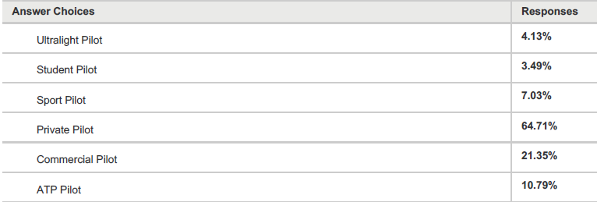

**Have you attained any of the following ratings/endorsement? (Column AV – BC)**

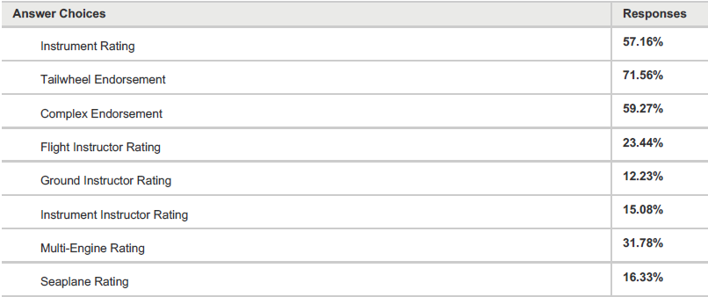

**How many hours have you logged as pilot in command? (Column BD)**

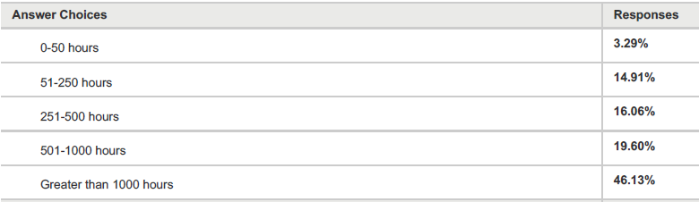

**On average, how often do you fly? (Column BE)**

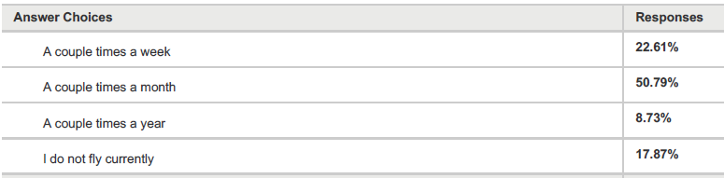

**How do you access an aircraft for flying? (Select all that apply) (Columns BF – BM)**

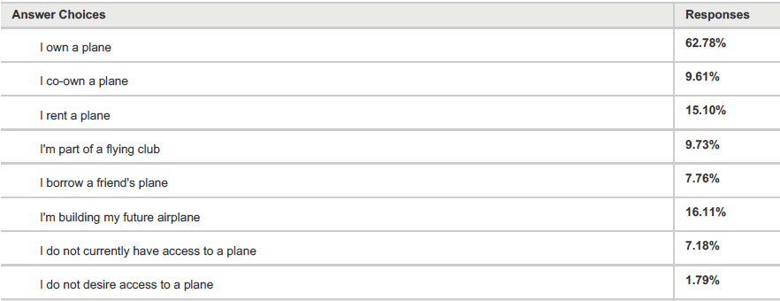

**What Level of Interest do you have in aircraft building? (Column BN)**

***(Scale of 1-5)***



**How involved are you with aircraft building currently? (BO – BT)**

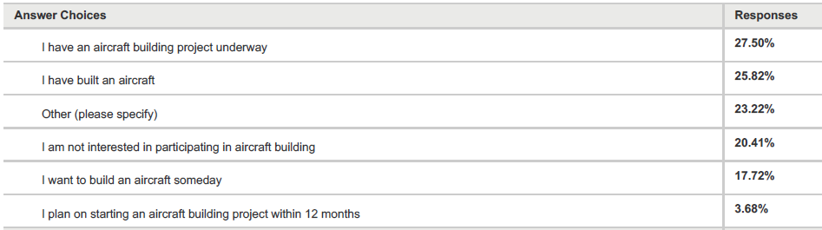

*\*Other (Please specify) is included as open ended commentary in column BT\**

**Please share any additional comments you have regarding EAA Chapters (Column BU)**

*Open ended commentary per your chapter is included on the excel spreadsheet.*

**Closing**

To build off your learnings from this survey, you are encouraged to attend a Chapter Leadership Training session. These training sessions are designed to make you a better chapter leader by covering nearly every topic applicable to running a successful chapter. You can visit [EAA.org/ChapterTraining](https://www.eaa.org/en/eaa/eaa-chapters/chapter-leadership-training) to learn about our upcoming sessions.

EAA’s Chapter Resource page, [EAA.org/ChapterResources](https://www.eaa.org/en/eaa/eaa-chapters/eaa-chapter-resources), is another great starting point when looking for ways to improve your chapter. The tools found on this page will help you promote, manage, and organize your chapter for long-term success.

Thank you for your continued commitment to sharing the Spirt of Aviation in your local area. Whether it be the completion of a chapter build project, a Young Eagle rally, or a chapter trip to EAA AirVenture Oshkosh, you truly make EAA the best aviation association, period.

If you have any questions or concerns, please do not hesitate to contact us with any questions you may have at [Chapter@EAA.org](mailto:Chapter@EAA.org).

**Tailwinds,**

**EAA’s Chapter Team**

Charlie Becker- Director of Chapters

[cbecker@eaa.org](mailto:cbecker@eaa.org)

John Egan- Chapter Manager

[Jegan@eaa.org](mailto:Jegan@eaa.org)

David Leiting- Chapter Outreach Specialist

[dleiting@eaa.org](mailto:dleiting@eaa.org)

Kyle Voltz- Chapter Field Rep.

[kvoltz@eaa.org](mailto:kvoltz@eaa.org)

Serena Kamps- Chapter Admin

[skamps@eaa.org](mailto:skamps@eaa.org)