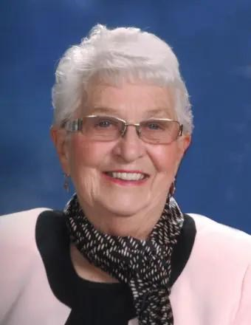 **Velva L. Quinn**

**December 14, 1935 - September 6, 2024**

**Mass of Christian Burial for Velva “Vel” L. Quinn, age 88, of Fairmont, MN, will be 10:30 a.m. on Saturday, September 14, 2024, at St. John Vianney Catholic Church in Fairmont with inurnment in Calvary Catholic Cemetery in Fairmont. Visitation will be 4:00 to 7:00 p.m. on Friday, September 13, at the Lakeview Funeral Home in Fairmont and will continue one hour prior to the service at the church on Saturday. Velva passed away on Friday morning, September 6, 2024, at her home in Fairmont. The Lakeview Funeral Home and Cremation Service in Fairmont is assisting the family with arrangements.**

**Velva LaVonne (Lenz) Quinn was born on December 14, 1935, at her family’s home in Estherville, IA. She was the daughter of Edward and LaVonne (McCoy) Lenz. Vel attended Estherville Community School District.**

**On September 7, 1957, Vel was united in marriage to Richard Solberg. This union was blessed with six children, Shelly, Lisa, Loni, Renata, Tonia, and Ilana. The family lived on a farm near Armstrong, IA, where Vel raised her family as well as helping around the farm.**

**On June 18, 1983, Vel was united in marriage to Allan Quinn in Fairmont, MN. Vel was blessed to gain stepchildren, Paula, Dennis, Duane, Daryl, Doug, and Darwin. Vel and Al shared over forty-one years together.**

**Vel worked as a nurse’s aide as well as working at Fairmont Ford, Chris Candy, and as a cook at St. John Vianney Catholic School until she retired at age sixty-two.**

**Vel was an active member of St. John Vianney Catholic Church as well as being a member of the S.O. Club and was a 4-H leader. During her free time, Vel enjoyed roller skating, swimming, dancing, and camping. She most loved the time she was able to spend with her family and friends.**

**Left to cherish her memory include her husband, Allan Quinn; children, Shelly (Karl) Andre, Lisa (Tom) Hansen, Renata (Steve) Moore, Tonia Kennedy, and Ilana (Jeff) Bohren; grandchildren, Valerie Sieren, Kenneth Andre, Jenna Hertrampf, Jordon Hansen, Jessica Moser, Wesley Moore, Courtney Mancuso, Kayloni Taylor, Bailee Shupp, Ian Smith, Rhianna Smith, Olivia Bohren, and Dustin Bohren; many great grandchildren; step children; Dennis (Linda) Quinn, Doug (Laurie) Quinn, Duane Quinn, and Darwin Quinn; son-in-law, Randy Mart; many step grandchildren and step great grandchildren; and numerous nieces, nephews, cousins, other relatives and friends.**

**Along with her parents, Edward and LaVonne Lenz, Vel was also preceded in death by her son, Loni Solberg; stepdaughter, Paula Mart; stepson, Daryl Quinn; and brothers, Murray Lenz, Leo Lenz, Leonard Lenz, and Murl Lenz.**

**Memorials are preferred to St. John Vianney Catholic Church or to the Cancer Foundation.**