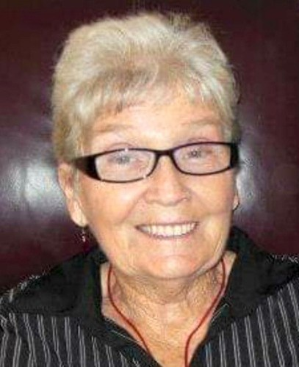 **Donna Lee Grant**

**December 27, 1933 - March 22, 2022**

**Donna Lee Grant, 88, of River Crossing of Moline and formerly of Cambridge, Illinois passed away Tuesday, March 22, 2022.**

**She was born December 27, 1933 in Kewanee, Illinois the daughter of A. Potter and Evelyn (Manthe) Brown.**

**She married Philip Grant on April 9, 1953 in Cambridge, Illinois.**

**He preceded her in death on May 21, 2014.**

**She is survived by two daughters: Teresa (Jerry) Grant-Quick of Coal Valley, IL, Regina Smith of St. Cloud, Florida; one son: Randy (Patricia) Grant of Wyanet, Illinois; seven grandchildren: Tanya, Josh, Brad, Sarah, Tuesday, Paige, and Danielle; and eight great-grandchildren: Deagan, Bentley, Stevie Jean, Soren, Willa, Lane, Nathan, and Justin; four great-great-grandchildren: Emma, Evelynn, Sterling, and Wren.**

**She was preceded in death by her parents, her husband, three children in infancy: Randy, Irving Philip, and Crystal Chell, and three brothers: Lowell Brown, Arnold Brown, and John "Jack" Heidenreich**

**Donna graduated from Kewanee High School with the Class of 1953.**

**She loved dancing, bingo, and going to garage sales. Donna also enjoyed time spent in Texas in the winter. She was the best pie maker in town.**

**A visitation will be held from 10:00-11:00 a.m. Saturday, March 26, 2022 at The BlackRidge 123 N. Prospect St. in Cambridge, Illinois with the service to follow at 11:00 a.m. at The BlackRidge on Saturday. Burial will take place in Rosedale Cemetery, Cambridge, Illinois. Memorials may be directed to the family for a memorial bench or the OSF Children's Hospital of Illinois, Peoria. Online condolences may be sent to**[**www.grant-johnsonfh.com**](https://www.grant-johnsonfh.com/)**.**