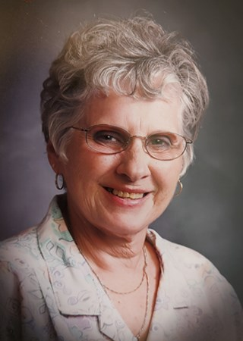 **Rita P. Knutson**

**February 26,1939 - June 8, 2024**

**Heaven has welcomed a new angel in Rita Patricia Knutson, 85 who passed away at her home in New Amsterdam, WI surrounded by her family and friends by her side singing her favorite songs to her on June 8, 2024.**

**She was born on February 26, 1939 in La Crosse, WI to William H. Kohlwey and Katherine M. Kohlwey (Freismuth). She graduated from Aquinas High School in La Crosse, WI. She married Kenneth Loomis and had 4 children, two daughters and two sons. They later divorced and she married Kent Knutson on June 29, 1996. She retired from Blount Industries/Outers in Onalaska, WI. Rita enjoyed many years of traveling the US and abroad with her sisters Kathleen and Dorothy, her brother & wife, Jim & Elaine Kohlwey, Husband Kent and good friends. Rita was the director of the Singles Club in La Crosse, WI and coordinated many trips for the club. Kent & Rita loved Square-Dancing and she also loved Line Dancing with her sisters Kathlene and Dorothy.**

**She was an amazing seamstress and made all her own Square-Dancing Dresses and even made Barbie Doll clothes for her daughters Barbie Dolls in her early years! She also participated in every craft there was to craft during their winters in AZ & TX. Kent & Rita spent many years in “Big Mamou” their Diesel Pusher Motorhome in AZ and later in Alamo, TX for the winter months. Kent is a musician and plays many instruments. He taught Rita how to play the Mandolin and they were in a band and also played in Jam Sessions during the winters in TX. Rita was known for her joyful and energetic personality and she was a fabulous dancer.**

**She is survived by her husband Kent Knutson, ex husband Kenneth Loomis, brother David (Arlene) Kohlwey, daughters Carla (Frank Green & Gary Kocimski) Green, Debra**

**(Patrick) Kowal, sons, Kenneth Jr. (Dawn) Loomis, Greg Loomis, Grandsons Matthew (Bobbi) Kocimski, Joshua (Terry) Kocimski, Kenny Loomis, Granddaughters Ashley, Mindy & Tiffany Dolan, Great Grandkids, Hannah (Tyler), Mikel & Mikayla Kocimski, Cedar & Juniper Kocimski, Kayla & Aiden Kell, Austin, Destiny, Brayden, Cayden, Aiden & Athena Loomis, Great Great Grandkid Cash along with many nieces and nephews.**

**She was preceded in death by her parents, William & Katherine Kohlwey, brothers Tom (Elaine), Jim (Elaine), & Paul (Bev) Kohlwey, sisters Dorothy Fischer, Caroline (Laird) Sloggy, Mary (George) Schraebeck & Kathleen Darling.**

**Rita was an amazing singer, musician and dancer a great mother, wife, sister and friend. She simply loved music and living an energetic and happy life. She will always be in our hearts and will be dearly missed by her family and friends.**

**A special acknowledgment and thank you goes out to the nurses and staff with Mayo Clinic Hospice and Comfort Keepers. A Celebration of Life Gathering will happen later this summer and all who loved her are invited to attend.**

**The family requests in lieu of flowers or other expressions of sympathy, you donate resources in any form to the hospice provider of your choice in Rita's honor.**

***A Celebration of Life Gathering is planned for August 24, 2024 from 11:00 am-4:00 pm at the Holmen Community Center, 600 North Holmen Dr, Holmen, WI. Lunch will be served. Everyone who knew Rita is welcome to attend. Please spread the word as it is hard to reach everyone.***