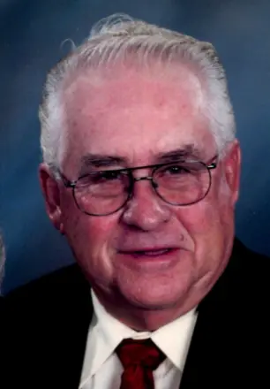 **Arlo Arkelle Sloan**

**January 29, 1938 - March 13, 2025**

**Arlo Arkelle Sloan, 87, of Cambridge, died on Thursday, March 13, 2025, at Silvis Center for Nursing Rehab, Silvis, IL. Funeral services will be held at 10:00 a.m., Tuesday, March 18th at Osco Community Church, Osco, IL. Rev. Paul Henschel will officiate. Burial will be in Rosedale Cemetery, Cambridge, with military honors. Visitation will be held on Monday, March 17th, from 4:00 to 7:00 p.m., at the church. Memorials may be made to the American Cancer Society. Stackhouse-Moore Cremation and Funeral Services is assisting the family with arrangements.**

**Arkelle was born on January 21, 1938, in Galesburg, IL, the son of Arlo Haywood and Gertrude Genevieve (Kapple) Sloan. Arkelle graduated from ROVA high school, Oneida, IL, in 1955. He served in the US Air Force from 1955-1959. He was united in marriage on August 23, 1959, to Verna Mae Carlson at Beulah Church in Orion, IL. She survives.**

**Arkelle had worked for John Deere, Moline, IL as a machinist and retired after 30 years. He was a member of Osco Community Church, Osco, IL and Geneseo Moose Lodge; and a former member of the Vikings Club in Moline, Cambridge American Legion, and New Windsor Sportman’s Club. He enjoyed vegetable gardening and flower gardening, fishing, and watching sports.**

**Those surviving include his wife, Verna; sons and daughter-in-law, Arlo Ray Sloan, Osco, and Gary Dean and Nancy Sloan, Naperville, IL; and son-in-law, Gary Firch, Geneseo. Other survivors include grandchildren, Amber (Nick) Casteel, Cambridge, Arlo B.R. Sloan, Alpha, Matthew (Claire) Sloan, Minneapolis, MN, Nathan Sloan, West Allis, WI, Jack Sloan, Downers Grove, IL and Jeff (Cara) Firch, Sterling, IL; step-grandchildren, Nick (Kristina) Iaizzo, Montreal, Canada, Athena (Louis) Iaizzo, Montreal, Canada, Melina Tiltin, Naperville, IL; and great grandchildren, Hailey, Madison, and Jase Casteel, Arlo, Kolm, and Knox Sloan, Vera Iaizzo, and Jace and Carter Firch; brother and sister-in-law, Richard (Dick) and Donna Sloan, Creve Coeur, IL; and sister and brother-in-law, Mary and Gary Meece, Sheridan, WY.**

**He was preceded in death by his parents; daughter, Shelly Lynn Firch; and three brothers, Kenny Ray, Gary Lee, and Duane Sloan**

**(Can send cards to: Verna Sloan, 406 E. Henry St., Cambridge, IL 61238)**